Chapter 2

Switch off

-by bassam elhijaji

As **hope** and **shine** escaped the room, **hope** decided to go after her father and to know every hidden secret awaiting her, but nightmares are sure waiting

**Shine** explained the whole story to **hope**

**Shine**: you were born in a kingdom named “**andulfoi”,** your parents were the king and the queen, and they always loved to discover mysteries, but you were the biggest mystery to them, because when you were born, a blue bright light filled the kingdom, you were the source of it, the people were so shocked of what happened the day after you were born.

**Hope**: what happened?

**Shine**: some had really bad injuries and diseases as consequences of the war, but your light……it…….

**Shine** was still shocked of the remarkable powers of **hope** that she showed at the day of her birth

**Hope**: shine?

**Shine**: it healed every single one, even those with small cuts and bruises, you father couldn’t believe it, so he was so busy unlocking your mysteries that he didn’t have time ruling his kingdom, and when he finally did it, **crow** showed up

**Hope**: who is he?

**Shine**: crow is a darkness slave who only feeds on the weak to gain their souls, and as a result he gets more power from them, as soon as he heard about your powers, he went insane for your soul, he showed up when you father discovered your mystery, but your father opened a dimensional gate to send you to “**asura**” the resident of dreams, **crow** spent every last drop of his powers to change the course of the gate.

**Hope**: so he switched the course of the gate to send me to “**Crimson city**”

**Shine**: exactly

**Hope**: I have two more questions……you said something about “consequences of a war”, what did you mean by that? And who is “**Asura**”?

**Shine**: I’m sorry but there is no time, give me your waist

As **hope** gave her waist to **shine**, the first power was reveled

**Shine**: ***inferope***

**Shine**s eyes shined bright while he was looking at her waist, suddenly a symbol reveled on **hope**s waist

**Hope**: what is this?

**Shine**: it’s a power symbol, it allows you produce a light from your plam, your father wanted me to give it to you, and all you got to do is to say ***infe-***

**Hope**: ***inferope!***

A bright light shined from **hope**s hand, it looked like it was coming from under her skin.

**Shine**: sigh………just….lets go…

**Hope**: where to?

**Shine**: remember the bugs that flew off your fathers’ message? Those are “beam” bugs, they can only be active if they got exposed by light, and they have the ability to give directions, your bug will lead us to “**Gaia**”, the nature fairy; so she can give you here power symbol.

**Hope** placed her hand underneath the message

**Hope**: ***inferope***

Her palm light went through the paper, making the **beam** bugs fly off

**Shine**: to the fairy of nature, **Gaia**

The bugs shattered in the midair, the pieces started to move in circles so fast, creating a dimensional portal surrounded by symbols



**Hope** felt so amazed by the power that the symbols hold

**Shine**: now then…...before you meet **Gaia**, let’s just say that she’s obsessed with…..riddles.

**Hope**: you met her?

**Shine**: sigh……this is going to be a long journey

**Hope** and **shine** went through the portal, teleporting them to the “nexus” forest

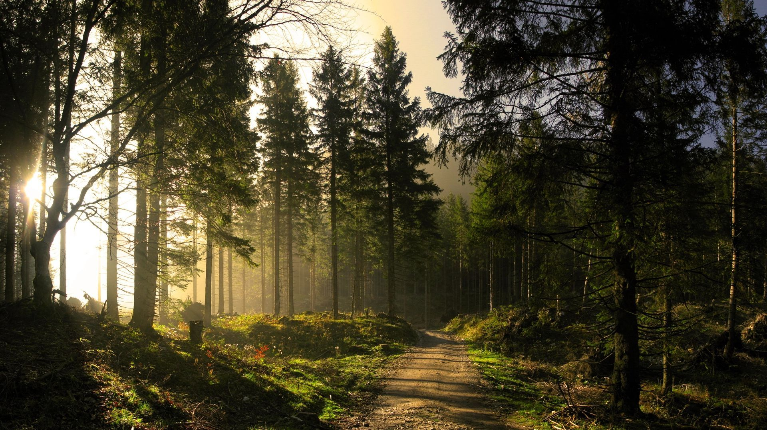

**Hope** saw the forest, she couldn’t believe such a beautiful, colorful place, she took the first steps, feeling the grass hits her naked feet, sun light warms her skin, and the sound of wind touching the tree leafs

**Hope** froze for few seconds, taking deep breaths, and then runs to forest leaving **shine** behind with a joyful smile and happy laughing tunes

**Shine**: hope! Wait!

**Hope** couldn’t hear **shine** calling; because she wanted to hear the sounds of nature only

**Shine** lost track of hope as he was chasing her

**Hope** got exhausted from all the running, she laid down at the closest tree

**Hope:** the colors, the sensations, the sounds

**Hope**: all of that, was hidden from **crimson** city

**Hope** got silent for a minute, she closed her eyes, focusing on the sounds of nature, then she heard something the sounded like a whale, she flinched a little

**Hope**: hello? Is someone here?

**Hope**: shine?

She heard wings striking the wind so fast behind the trees, the sound was changing its position too quick, she couldn’t locate it

**??? : who** are you? And what are you doing in my forest?

**Hope**: your forest? So you are **gaia?**

**???**: that depends on who’s asking

**Hope**: I’m hope, I was born in **alfanoi**, but I got thrown in **crimson** city, I’m trying to get there, can you help me please?

**???**: alfanoi!? How can such a delightful kingdoms citizen be living in **crimson** city?

**Hope**: it was **crow**

The wings sound stopped, it was dead silent for few seconds

**???**: how about we play a game, a riddle game

**Hope**: ok?

**???**: if you can answer my riddle, I’ll show myself and help you get to **alfanoi**

**???**: but if you don’t, I’ll take that lovely power symbol you have on your waist

**Hope** felt a great danger, her heart beat got faster

**Hope**: DEAL!

**???**: a women was cleaning her house, all of sudden someone was knocking on the door, she opens the door and it was a man, he said “I’m sorry, I thought it was my house” and then left, the women immediately called the guards help, why did she thought the man was so suspicious?

**Hope** was so lost, she was thinking that any mistake will cost her the power symbol, she stared at her symbol and thought over and over, until the solution popped in her head, **hope** smiled a half way smile

**Hope**: you don’t knock on your own home

**Shine**s calls and yells was gradually getting close to **hope,** until he found her

**Shine**: HOPE! God dame it, WHAT WERE YOU THINKING?!

**Hope** gave **shine** a proud smile

**Hope:** sorry…

Suddenly **Gaia** came out from the bushes, a blonde hair, white dress, and a beautiful bug wings, **Shine** made a grumpy face as he saw her

**Shine:** oh great…

**Gaia**: come on you little hair ball, it’s been so long since our last fight and you give me that ugly face?

**Shine**: hey! That was uncalled for!

**Gaia**: your face is uncalled for

**Shine**: YOU WANT TO DO THIS NOW?!

**Gaia** smiled and hit her palm with her fist

**Gaia**: LET’S GO FISHY BREATH!!

**Hope** interrupted them as she laughed at them, they stared at her for few seconds

**Shine**: sigh…..listen, I didn’t come here to make troubles we just need your power symbol and the **beam bug**

**Gaia**: oh come on, leaving so fast? How about you stay at my home today and leave tomorrow, you guys look tired

**Shine** thought of what **hope** went through, he didn’t have a choice but to accept the offer

**Shine**: FINE!

**Gaia**: well that’s strange, you’ve always been hard to convince